ELECTRIC CURRENT AND VOLTAGE
Name: ____________________Class: 12th Grade (4° Medio) Teacher: Valentina Espinoza
Date: April, 2020.
Objective: know and recognize vocabulary related to current and voltage.

- Read the text. Then, answer.

Current is the amount of electricity flowing around a circuit. Current carries energy to the components of the circuit; that is why light bulbs you use at school light up. Large current makes bulbs bright, whereas a low current would make them dim.

Current is measured using ammeters. Diagram 1 shows an analogue ammeter, whereas diagram 2 shows a digital multimeter, which is used as an ammeter amongst other uses. You are likely to use a digital ammeter at school these days.
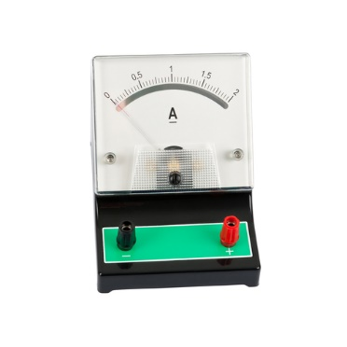 | 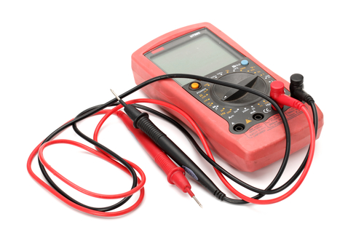
Diagram 1 | Diagram 2

An ammeter is connected in a circuit in series. This means it is part of the circuit loop (see diagram). The position of the ammeter does not really matter, because the current is the same anywhere in the circuit. Current is not used up as it goes around the circuit. The unit of measuring current is called ampére. We abbreviate this as amps and the symbol is A.
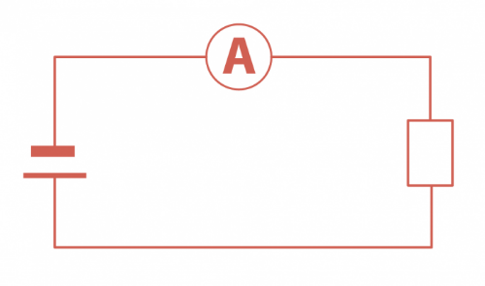
Current in a circuit can be changed by changing the circuit components. For example, if a circuit has one bulb and the current is 0.3 A, it will drop if we add another bulb. Light bulbs have very small wires in them called filaments (see the orange wire in bulb picture).
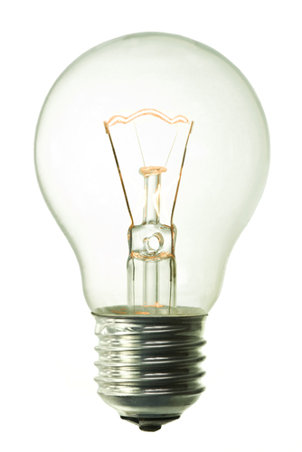
Filaments make it very hard for the current to flow, so adding another one makes it even harder. We say that filaments carry resistance, which makes it harder for current to go through them. Resistance is measured in Ohms (Ω). The formula used to calculate resistance is:

resistance = voltage / current
Voltage is the measurement of how much energy is transferred by electricity. It is measured in volts (V) with a device called a voltmeter. A voltmeter looks like an ammeter but it measures voltage. Voltmeters are always connected in a circuit in parallel to a component (see example in diagram: the voltmeter, shown as V, is connected in parallel to the light bulb).

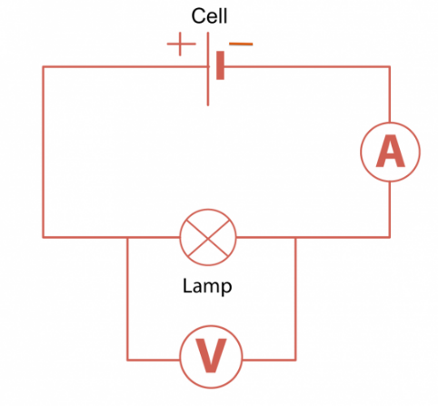
Cells have a voltage marked on them. The bigger the voltage, the higher the current. Chemicals inside cells provide the voltage.

- What is voltaje?

- How can you measure the current?

- What do diagram 1 and 2 show?

- Is it important the position os an ammeter? Why? Why not?

- What is an ampere?

- How can tou measure “resistance”?

- How can you define voltage?

- What is a voltemeter?

