ELECTRICITY
Name: ____________________Class: 11th Grade (3° Medio) Teacher: Valentina Espinoza
Date: May, 2020.
Objective: Learn basic vocabulary.

LIGHT BULB ANATOMY
- Provide the labels for the parts of the incandescent light bulb shown below using the following:
Base
Contact
Glass support
Bulb
Filament
Connecting and supporting wires

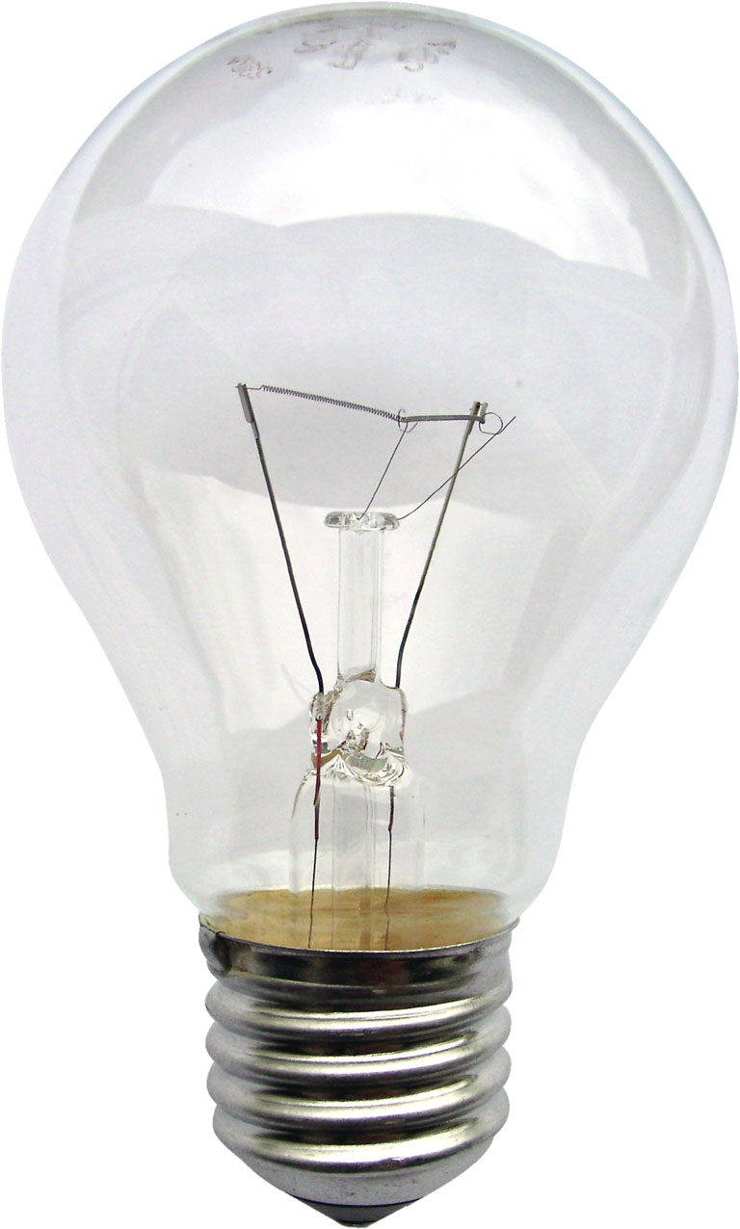

- Vocabulary
Write the definitions in the appropriate place.
- Producing energy through charged particles.
- Natural magnetized materials that are used as magnets.
- To pull together with physical force.
- To move or force back or away.
- A metal core that's soft that creates a very strong magnet after a current passes through wire that is coiled around it.
- A device used to show direction that contains a magnetized pointer.
- The Flow of electricity through a wire.
- A small particle that carries one unit of negative energy.
- An object that has an electric charge and can be used as energy.
- An object made out of material such as iron that have magnetic properties.
- Power that's active.
- The entire path or part of the path that over which an electric current flows.

current
electricity
electromagnet
electron
force
lodestone
magnet
attract
battery
repel
circuit
compass

