English Department
Mister Rodrigo Cortés M.
ENGLISH WORKSHEET
Name _______________________ Class: ______ Date: _________________
MY BEDROOM IS MY WORLD
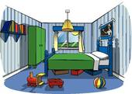
For many teenagers, their bedroom is the place where they spend most of their time. And so, they decorate it with pictures, posters or other stuff that represent them. They do more than sleep in there, it’s where they listen to music, do homework, play videogames, read or even eat. Which of these pieces of furniture have become essential in your bedroom?
laptop | TV | fridge | bookcase | mirror | air conditioner

Read these descriptions of bedrooms and match them with the person you think they belong to.
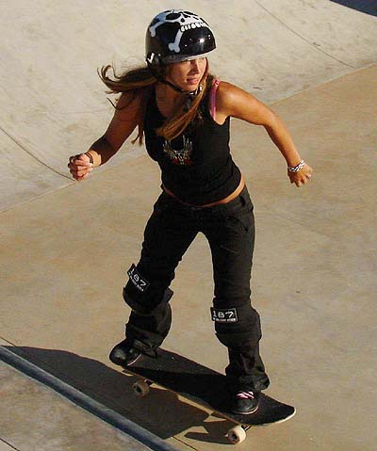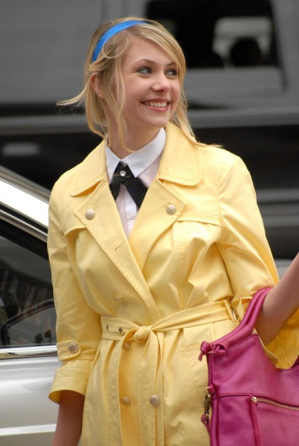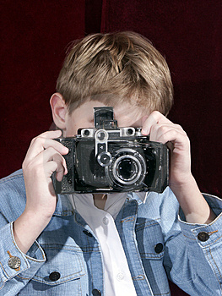
- My bedroom is my favourite place. I spend a lot of time there. There is a big desk and a comfortable chair. My computer is always on. I have a small window but there is a big lamp. I have some maps on the wall and a big world globe. There is a bunk bed. I have 3 bookcases full of books because I love reading. There isn’t a TV.

- My bedroom is a bit untidy. I am always outside, I don’t spend too much time in my bedroom. There are clothes on the bed and on the chair. When my friends come visit me, we sit on a sofa in front of the TV. I have a big TV in my bedroom because I love videogames. There are many posters of music bands on the wall. And my favourite thing: my skateboard, is next to the door.

- I have a big bedroom. My wardrobe is huge because I have many clothes. There are two big mirrors and a big window. I like bedrooms with bright colours. There are two bedside tables next to my bed. I have a jewellery box where I keep my rings and bracelets. There aren’t any desks because I do the homework in the studio.

- We live in a small flat, so my bedroom isn’t very big, but I’ve got everything I need. There is a desk with my school books and a lamp. My laptop is on the desk. It’s a very good laptop because I use it for my hobby. I have many picture frames on the wall. My bed is small but I have a beautiful headboard. I love taking photos so I keep my photography material in my drawer.

Look at the underlined words and match them with the correct pictures. There are 2 extra words. What type of words are they?
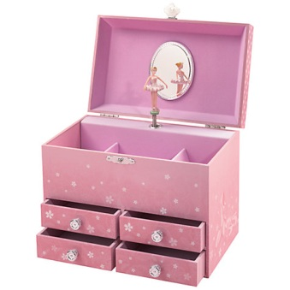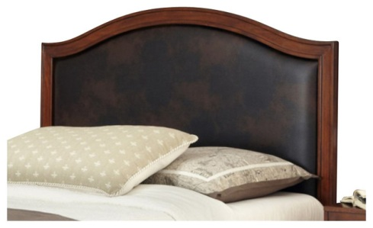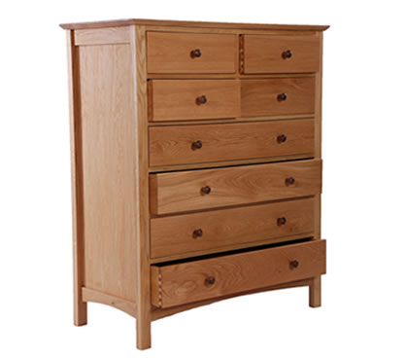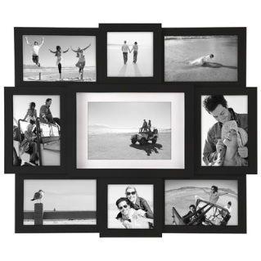
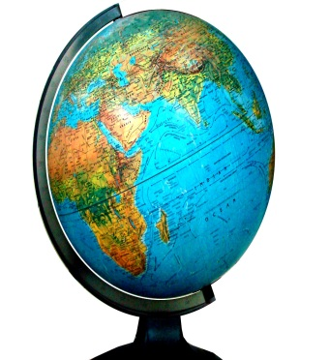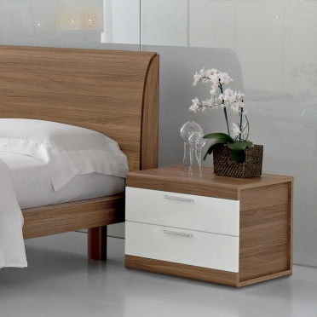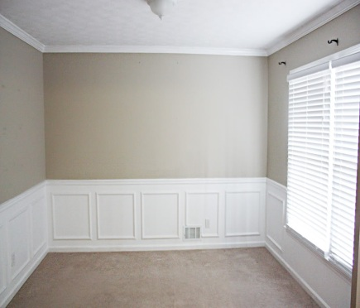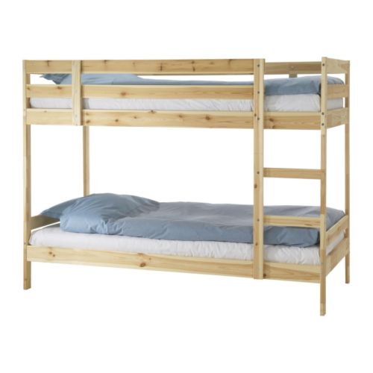
Write a description of your ideal bedroom. What would you like to have? What colour would you paint it? You can think of crazy ideas.

There are some free time activities or hobbies that need a lot of equipment. What do you need to practice these activities? Which ones do you think are more interesting? What are the most popular activities in your group of friends? Describe the activity in no less than 100 words
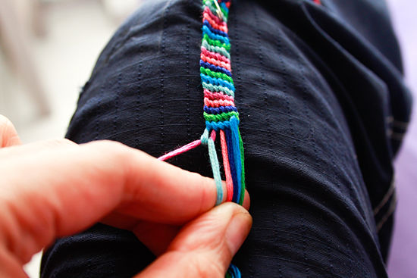
- photography
- skating
- painting
- handicrafts
- playing music
- cooking
- other: _______________________
________________________________________________________________________________________________________________________________________________________________________________________________________________________________________________________________________________________________________________________________________________________________________________________________________________________________________________________________________________________________________________________________________________________________________________________________________________________________________________________________________________________________________________________________________________________________________________________________________________________________

