UNIT 1: PEOPLE AND OUR BELIEFS
Name: ____________________Class: 12th Grade (4° Medio) Teacher: Valentina Espinoza
Date: May, 2020.
Objective: Respecting and valuing the importance of legends for a culture. Reinforce writing skills

LESSON 3 URBAN LEGENDS
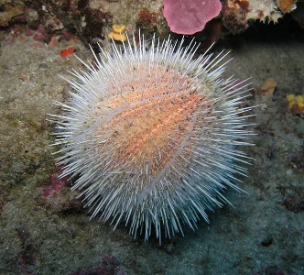
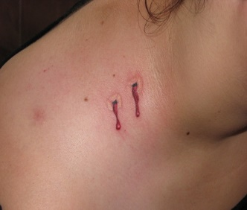
- KEY WORDS: Write the concept.(see the underlined words in the texts below)

___________________ ___________________

___________________ ___________________ ___________________

___________________ ___________________
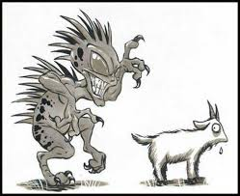
- Read the texts.
EL CHUPACABRAS
The name Chupacabra comes from the beast’s reported habit of attacking and drinking the blood of farm animals, especially goats, similar to what a vampire does.
Physical descriptions of the creature vary. The first person to see it said it had a ‘reptilian body, oval head, bulging red eyes, fanged teeth and a long, darting tongue’. In other reports, its height was approximately 1 to 1.2m high, and it stood and hopped like a kangaroo. It also made hissing sounds and had a terrible odour. Another description mentioned a heavy creature, like a small bear, with spikes from the neck to the tail.
Where did the myth originate? The world first heard of this new vampire beast from a lady in Puerto Rico in 1995. She reported that eight of her sheep died with bite marks and no blood left in their bodies. Other events in the country followed and finally, a comedian spoke about the chupacabra.
LA LLORONA
Once a poor man was married to a beautiful woman who lived in his village. The couple was very much in love, but the man insisted that they were too poor to have any children. When he found out his wife was pregnant, the man was very angry. He told the woman they could not keep the child. After the birth of his son, the man drowned the child in the river. His wife, too weak from giving birth to get up from the bed, pleaded in vain with her husband to spare the life of her child.
Several more sons were born to the couple, and the poor man drowned every one. The day the poor man took his fifth child to the river, his wife followed even though she was still weak and bleeding from giving birth. When he threw the child in the river, the woman went in after her son, determined to save the boy even though she did not know how to swim. The woman and her baby were swept away by the current and they both drowned.
From that day to this, the spirit of La Llorona -- the wailing woman -- still haunts the waters and lakes, weeping and wailing and searching for her sons.
- From 1-4, circle the right answer:
- “La llorona” until this day is:  a) haunting the waters to find her sons  b) weeping for her husband and sons  c) searching her son  d) drowning her sons  - “La llorona” gave birth to:  - Three children  - Two children  - Five children  - One child | 3) “El Chupacabras” likes the blood of:  a) Goats  b) Children  c) Kangaroos  d) Vampires  - In his first attack “El Chupacabras” killed:  - Eight sheeps  - Twelve goats  - Five sheeps and three goats  - Two sheeps

- Write true (T) or false (F).
- ___ The world first heard about the Chupacabra in Puerto Rico.
- ___ “La Llorona” is looking for her lost dog.
- ___ “El Chupacabra eats burgers and drink Coca-Cola.
- ___ “La Llorona” jumped to a river to try to save her fifth child.
- ___ The first person that saw the Chupacabra said: “it had a reptilian body”.
- ___ “La Llorona” and her husband were poor when they got married.

- Answer the following questions.
- Why do you think urban legends emerge? Explain
________________________________________________________________________________________________________________________________________________
- What can urban legends tell us about a culture?
________________________________________________________________________________________________________________________________________________

- Linguistic reinforcement
“How to write a ‘Legend’”.
- First of all, create a character and describe her/him in detail, for example “it had a ‘reptilian body, oval head, bulging red eyes”
- Secondly, choose a context with a place or a period of time, to let the people know when happened.
- Thirdly, it has a theme, which means that the legends it’s telling a story.
- Finally, it’s narrated in 3rd person and has an open-ended final, to let the people to narrate the story.
DON’T FORGET TO USE A LOT OF ADJECTIVES!!! and the legend must include an introduction, a body and an end.

- Write your own legend (120-90 words)
________________________________________________________________________________________________________________________________________________________________________________________________________________________________________________________________________________________________________________________________________________________________________________________________________________________________________________________________________________________________________________________________________________________________________________________________________________________________________________________________________________________________________________________________________________________________________________________________________________________________________________________________________________________________________________________________________________________________________________________________________________________________________________________________________________________________________________________________________________________________________________________________________________________________________________________________________________________________________________________________________________________________________________________________________________________________________________________________________________________________________________________________________________________________________________________________________________________________________________________________________________________________________________________________________________________________________________________________________________________________________________________________________________________________________________________________________________________________________________________________________________________________________________________________________________________________________________________________________________________________________________________________________________________________________________________________________________________________

